 **MATHEMATICS APPLICATIONS**

**Test 6 2018**

**Piecewise and Simultaneous Linear Functions**

**Resource Free**

**Marks: 22 Time Allowed: 25 minutes**

**TOTAL: 47 Name: _______________**

**ALL** working must be shown for full marks.

**For full marks you will need to show all your working out.**

**Question 1** **[2, 3, 3 = 8 marks]**

1. Solve the following Linear functions

**i)** 4y - 6 = 30 **ii)** 3(x + 8) - 2 = 7

1. **Give the equation** that represents the following situation and **then solve** to find the value of x.

“Three times a number is divided by four and then two is added. The result is one less than the original number”

**Question 2 [3, 3 = 6 marks]**

Solve the following simultaneous equations using the method stated below.

1. 2x + 3y = 6 and 5x – 3y = -27 by **Elimination** method.
2. x - 3y = 7 and y = x – 1 by **Substitution** method.

**Question 3** **[3 marks]**

Graph the following function on the axis below.

y = -x -3 x ≤ -5

y = 1 -5 ‹ x ‹ 1

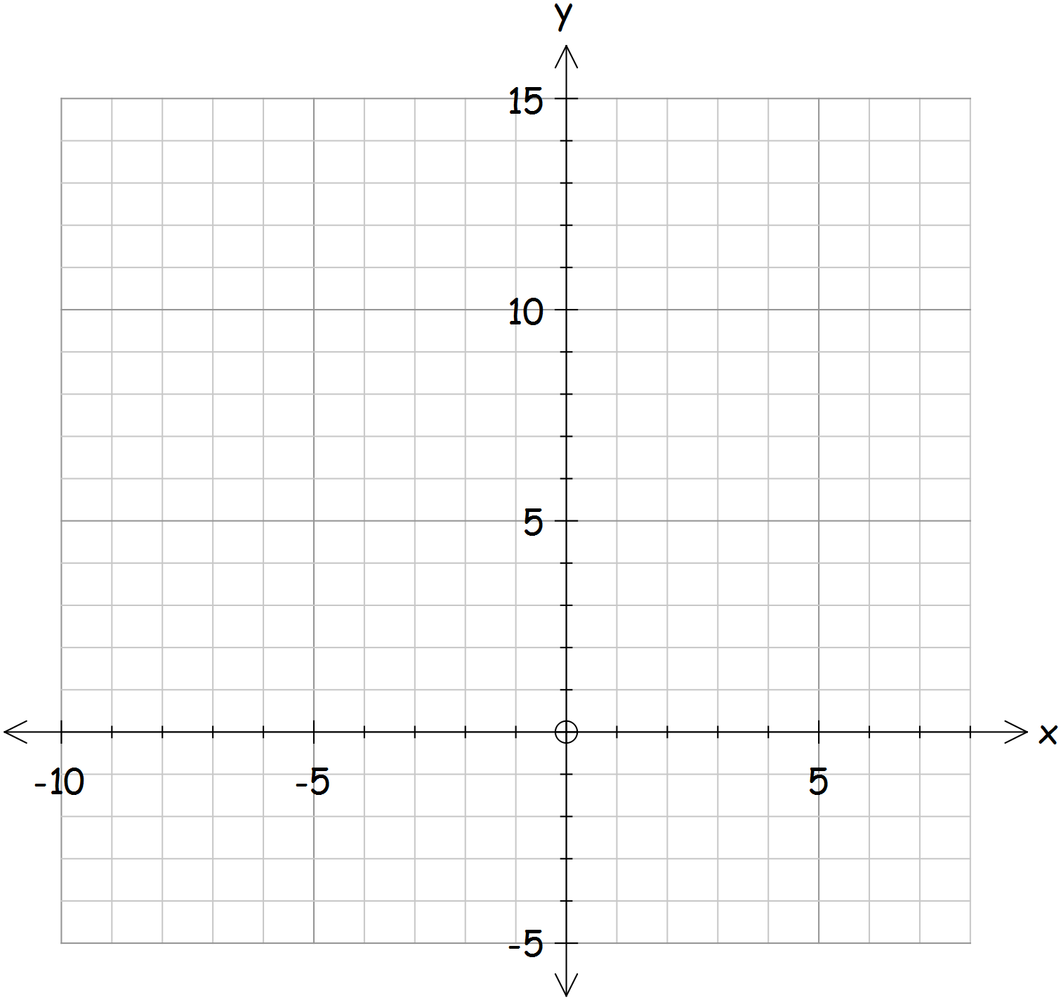

y = 3x 1 ≤ x

**Question 4**  **[4, 1 = 5 marks]**

1. Sketch the graph for the following equations y = 6 - 2x and 5y = 10x + 10.

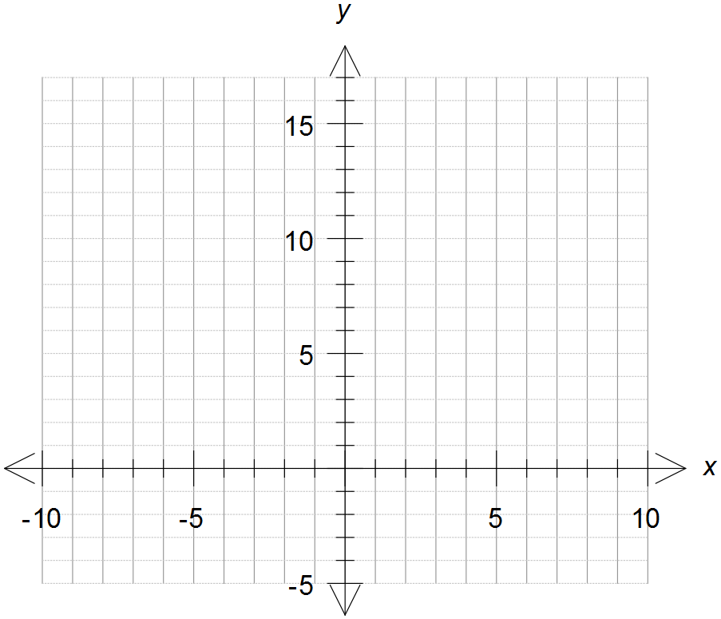

1. Find the point of intersection for the two equations from the graph.

**MATHEMATICS APPLICATIONS**

**Test 6 2018**

**Linear Functions**

**Section B-Resource Assumed**

**Marks: 25 Time Allowed: 25 minutes**

**ALL** working must be shown for full marks.

**Question 1**  **[2, 2 = 4 marks]**

Find the point of intersection between the following equations

1. y = 2x + 10 and y = 3.5x + 0.5
2. 5(2x – y) + 4y = 3(3x + 1) and 5(2x – 1) =5x – 2y + 38

**Question 2**  **[2, 2 = 4 marks]**

To promote the school Fete two poster companies have considered.

Polly’s posters charge $175 to design the poster and $3 for each poster she makes.

Pete’s posters charge $250 to design the poster and $2 for each poster he makes.

1. Write down an equation to find the cost of producing (n) posters for each company.

Use C for the cost and n for the number of posters.

1. What company should the school use if they need 40 posters. Why?

**Question 3**  **[2, 1, 1, 1, 2 = 7 marks]**

The piecewise graph below shows the annual premium (cost) of life insurance for men of different ages.

1. 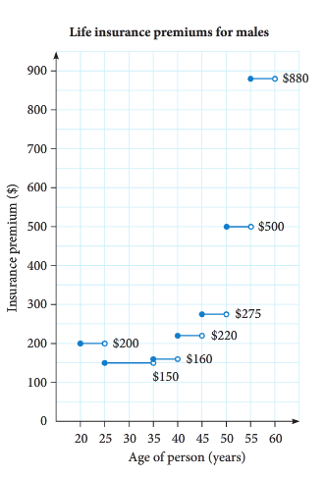What is the annual premium for a man aged:
2. 24 years?
3. 52 years?
4. Why is the cost different?
5. For what age group is the cost $275
6. What is the age of the youngest man who

can pay a premium of $160.

1. For what age ranges does the price reduce

as you get older? Why?

**Question 4 [2, 2, 1, 2, 1, 2 = 10 marks]**

Amber is a plumber. She charges $60 for arriving at a job, and $75 per hour that she works.

1. Use the information above to complete this table

|  |  |  |  |  |  |
| --- | --- | --- | --- | --- | --- |
| **Time worked, t (hours)** | 0 | 1 | 2 | 3 | 10 |
| **Cost,C($)** |  |  |  |  |  |

1. Graph the data in the table on the axis below.

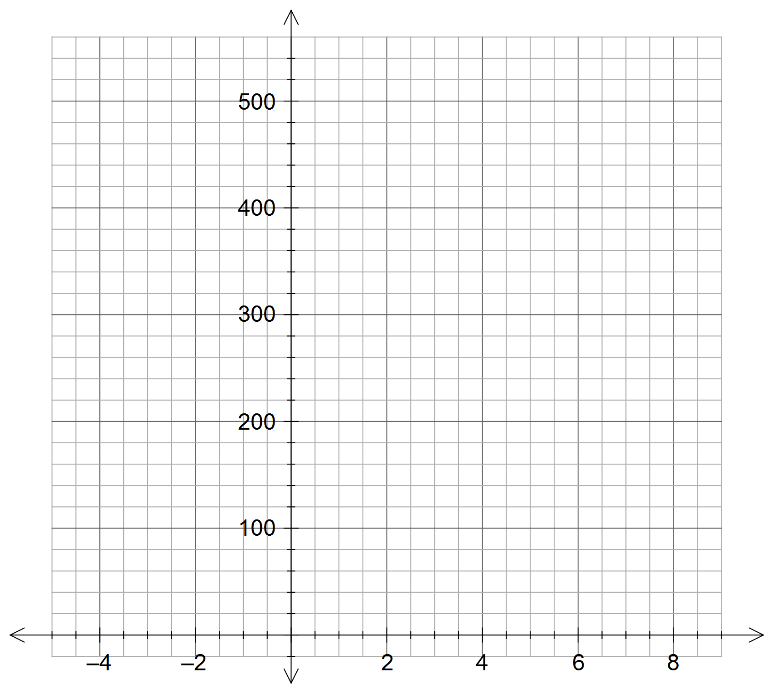

1. What is the significance of the intercept on the y axis?
2. Determine the equation of the line for the relationship between t and C.

(must be in terms of **t** and **c**)

1. What is the significance of the Gradient?
2. Use your graph to answer the following questions

**i)** How much would Amber charge for working 6 hours?

**ii)** How long has Amber worked if she charges $360?